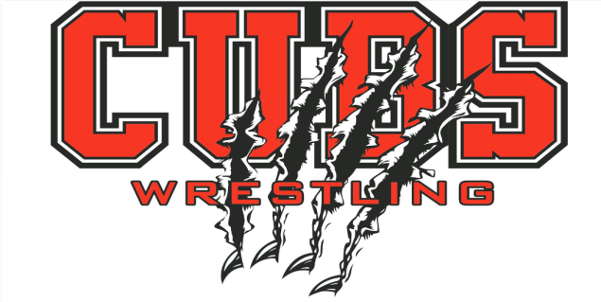

## CHAMBERLAIN YOUTH WRESTLING TOURNAMENT

# National Guard Armory

# Chamberlain, SD

## Sunday, January 20, 2019

**CHECK IN: 9:30 am-11:00 am (No Check In after 11:00 a.m.)**

**START TIME: 12:00 pm**

**COSTS: $10.00 entry fee per wrestler paid online at registration. $5 Coaches Band**

**Adults $5 / Students $3**

**Pre-Registration Required**

* ALL ENTRIES DUE BY Midnight **Thursday, January 17th  (No Exceptions)**
  + **Register online at trackwrestling.com**
* Contact/Questions:
  + Brad Biggins- Phone: (605)840-0556 or Email: bradbiggins@icloud.com

**Information**

* 2019 Boys & Girls AAU Age Divisions: 6 & under: 7-8; 9-10; 11-12; 13-14 (Matched as close to weight as possible) Girls wrestle with boys
* AAU Cards and Birth Certificates Required. Will be checked.
* 3 – 1 minute 30 second Rounds
* 4 Man Brackets (Round Robin)
* Trophies for 1st, Medals for 2nd-4th (No Match - No Trophy)

**Concessions will be served by Chamberlain AAU Wrestling Club**

**No Coolers Please**

This event is licensed by Amateur Athletic Union of the US, Inc.

All participants must have a current AAU membership.

AAU Membership may not be included as part of the entry fee to the event.

AAU Youth Athlete membership must be obtained before the competition begins except where the event operator has a laptop available with an internet connection.

BE PREPARED: Adult and Non Athlete memberships are no longer instant and cannot be applied for at event. Please allow 10 days for membership to be processed.

Participants are encouraged to visit the AAU website [www.aausports.org](http://www.aausports.org) to obtain their membership.